Geoff Weller
Loc: Mid Wales
Skipper 17 info sought
#1522774 - 22/07/2007 10:29

I intend to construct an informative website on the Skipper 17 trailer-sailor. I am looking for any information - history, technical, instruction sheets, publications, experiences, modifications, etc, in short, everything that anybody is willing to contribute. Please contact me if you can help.
Old_Gold
Loc: Anglesey
Re: Skipper 17 info sought [Re: Geoff Weller]
#1525423 - 24/07/2007 22:11

HI, there was a super forum for skippers but was shut down due to spamming, wish I had printed it all off as there was a weath of information on everything from renewing windows to rigging info, when I get home this weekend I'll look up any info I have and post it. In the process of restoring number 98 single keel myself, phew! ..
geoffatstanpit
Loc: Christchurch UK
Re: Skipper 17 info sought [Re: Geoff Weller]
#1525471 - 24/07/2007 22:44

My very first boat, sail No 74. Bought 1979 sold 1981 to a chap in Ashlett Creek - and it was still there looking neat and tidy last time I was there in 2003. It is the central single drop keel version, replaced soon after by the double drop keels giving a clear cabin floor. Cracking little boat but not big enough for 3 of us.
MrCramp
Loc: Nottinghamshire
Re: Skipper 17 info sought [Re: Geoff Weller]
#1525579 - 25/07/2007 00:38

I had one for 10 years, a cracking little boat. Was one of the earlier twin keel versions. Had some good voyages in her and slept in the cockpit under a tent with my two mates in the cabin. The moulds were bought by Morton Boats who manufactured the Eagle 525 from them.
They are an underrated boat. My two mates also bought one each, but that was 7 years ago and now we have moved on. Good Luck.
graham

Re: Skipper 17 info sought [Re: Geoff Weller]
#1527810 - 26/07/2007 19:41

I was anchored in Porlock Bay a few weeks ago in strong wind debating whether or not the weather was suitable to set off for Cardiff in our 22 Footer. Next minute a mustard brown coloured Skipper 17 went flying past no problem.
Has anyone done any epic voyages in one?
Harry_Tate

Re: Skipper 17 info sought [Re: Geoff Weller]
#1531065 - 30/07/2007 17:15

Great little boats - I've got a twin lifting keel cabin boat which I keep at Chatham, although it really does deserve that refurbishment which I've been promising it all year. Two or three of us sail it a lot out on the estuary and it always feels safe, even when taking a hammering in a considerable blow. Three full sized blokes for the occasional weekend too, with two of us sleeping in the cockpit on the 6' cushioned sidebenches in bivvy bags, and the other inside. The remaining berth holds the wine, food etc.
I also hire a single drop plate dayboat Skipper 17 when we go on holiday to Cornwall every year. It copes with open sea conditions admirably for a small boat.
Great idea, the website. These boats are underated.
George
Geoff Weller
Re: Skipper 17 info sought [Re: Harry_Tate]
#1532377 - 31/07/2007 20:49
I sailed a friend's Skipper 17 (single plate version) on Sunday and was I very impressed at its performance and stability, even though it has sails from an Albacore. I am launching my own boat (twin plate version) tomorrow at Llyn Clywedog (Mid Wales). I hope it performs as well at my mate's boat - if so I shall be well satisfied.
Geoff Weller.
Geoff Weller
Skipper 17 Website Launched
#1538687 - 07/08/2007 19:26
The Skipper 17 Website is now available at http://myweb.tiscali.co.uk/skipper17/ (I am the Webmaster)
I am still developing the site, and I still need more information that would be of use to other Skipper 17 owners. If any reader has anything further to contribute, please let me know.
Alfie168
Re: Skipper 17 Website Launched [Re: Geoff Weller]
#1540084 - 08/08/2007 22:34

I've always felt well disposed to these little boats, and indeed to almost anything designed by Peter Milne. (The Fireball has to be his masterpiece though IMHO)
I was however slightly less well disposed to one on Sunday at Rutland Water. The poor owners had got one of the keel plates stuck down, but they ended up rather blocking the very busy slipway, and whilst everyone remained friendly, some of the smiles got a little tighter. I hope they got it sorted.
There are quite a few at Rutland incidentally, at least five and maybe more at a guess.
Tim
Geoff Weller
Re: Skipper 17 Website Launched [Re: Alfie168]
#1542009 - 10/08/2007 18:43

The previous owner of my boat had a piece of rope tied to the bottom of each keel, and led up to the cockpit. He explained that he used to keep the boat on a mud berth, and the keel slots regularly got full of mud and jammed the plates in the up position. He used a boathook to push the rope down to unstick the keels. But he didn't tell me how to get the plates up again if they were stuck down.
Do you have a contact at Rutland who has a Skipper 17? I feel there must be a lot more documentation in peoples' cupboards that would be useful to others if I put it on the website.
From: Adrian Jennings
Skipper 17 info
29/08/2007 22.39

Hello Geoff
I have recently purchased a Skipper 17, kept at Rutland Water and have enjoyed your website . Here are some article contributions acquired from the previous owner who restored the boat. Also some pictures of the boat (Sirius 2).
Regards
Adrian Jennings
PS Also have some boat test articles purchased on-line but not sure on the copyright on these.
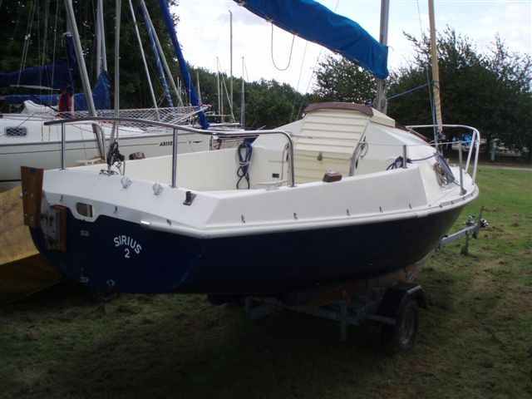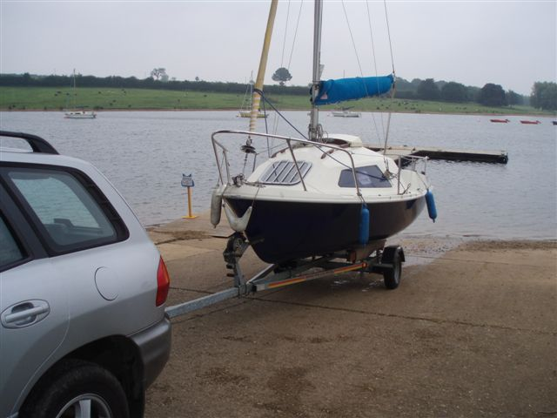

From: Geoff Weller
31 August 2007 17:52

Re: Skipper 17 info

Hi Adrian
Thank you very much for the information and pictures.
You have certainly purchased a fine looking Skipper 17. I hope that you are enjoying sailing Sirius 2 on Rutland Water as much as I am enjoying sailing Vera Causa on Llyn Clywedog. I have read somewhere that there are several S17's at Rutland. Perhaps we should organise a National S17 Rally at Rutland next year. Incidentally, if you get any action photos of your own boat or any other S17's, please email them to me.
It is interesting to note the different modifications that owners have made to their boats. I see that yours has rowlocks on the cockpit coamings. But where do you sit when you need to row?
The printed sheets you sent, will appear on the website in the next few days. One of them was the missing second page of a publication that I had already put on there. I am troubled by the sheet describing "Skipper Mariner and Skipper Mate" because it doesn't fit into my understanding of the history of the S17. I obviously have some more research to do.
I have three boat tests on my desk, all purchased from Practical Boat Owner, which I can't use on the website because of copyright. These are:
PBO No 386 Feb 1999 by David Harding (Eagle 525)
PBO No 307 Jul 92 by Dave Greenwell (Eagle 525)
PBO No 413 May 2001 David Harding (Choosing a Trailer-Sailer)
If you have any other tests (apart from the one already on the website - "Sweet 17") I would certainly appreciate a scanned copy. I will investigate whether copyright applies or not.
Fair weather and a fresh breeze
Best regards
Geoff.
From: Adrian Jennings
31/08/2007 22:34
Re: Skipper 17 info

Thanks for your reply Geoff
I only have the boat tests you describe apart from the 1999 one. There are probably 6 - 8 Skipper 17s and 2-3 Eagle 525s at Whitwell on the North side of Rutland water where I am currently based. Will send some pictures of them . Not sure how many on the South shore sailing club. Last Bank holiday there were 4 Skipper 17s sailing at Rutland which was fun to see and I chatted to some of the owners. A couple of the Skipper 17s are in a bad state, with at least one impounded due to neglect which is sad to see and has birds nesting in it! Another, in reasonable condition with a central keel has recently been up for sale at £1100 including an electric outboard. I paid £1700 for mine and I note that a similar one is for sale at http://www.thetrailersailercentre.co.uk/ for £3250 so quite a price range but good value intro to sailing larger boats. The history is interesting and a bit like a VW camper on water! Mine has a Mariner plate on it, which I will send a photo of. Maybe you have a photo of your boat?
As far a rowing ……guess you could stand, bit like sculling, if that is the right term. I have wooden oars and rowlocks, but tend to use paddles to get back into the mooring when the wind has dropped.
Boat is on the pontoon tonight, so ready for the weekend if the wind is right. Not sure about stronger winds as it’s my first larger boat so do not know how much heel she can take. Some models seem to be self righting, but not sure about mine, and don’t want to find out !
Incidentally I seem to get a pool of water on the cabin floor ….any suggestions as the windows and hatch look sound?
Cheers
Adrian
From: Geoff Weller
01/09/2007 18.44

Re: Skipper 17 info

Hello again Adrian
Your boat is better than the one at "thetrailersailercentre" because the latter has the central drop plate and therefore an obstructed cabin floor.
I think you paid a fair price for yours. I paid £1800 privately after my wife (an expert negotiator) haggled the unfortunate seller's price down from £2,500! There is an S17 on eBay at present with a buy-it-now price of £1800
We renamed our boat Vera Causa, and she (the boat) is shown on the website at http://myweb.tiscali.co.uk/skipper17/descriptionpage2.html. I am the old bloke on deck with the sunglasses putting the mast up. You can just see the only other Skipper 17 (light blue) at Clywedog in the background of the second picture.
Vera Causa is a sort of cream ivory colour (not white) on top, and dark blue underneath. The dark blue bit has been painted for some unknown reason. The original gel coat colour shows through in places where the paint has dropped off, and is an almost identical dark blue.
My boat's nameplate shows the date (1979), the boat number (= sail number I assume) and the builder, Anderson Rigden and Perkins. There is no mention of the word "Mariner". I would be interested to receive a photo of your nameplate as it would perhaps be a useful piece in the historical jigsaw.
I have found a couple of other references to "Skipper Mariner" on the internet, both implying that this name was applied to the Skipper 17 design at some time. I have absolutely no idea what the Skipper Mate was.
If you get a pool of water on the front cushion after rain, it is coming through the front hatch: this is a common problem because the seal perishes with age. The hatch is a Houdini Hatch and amazingly is still made after all these years. A replacement seal is available from Safety Marine at http://www.safety-marine.co.uk/Hatches-&-Ventilation/P4043S18/Houdini-Super-50-Hatch-Spare-Seal.htm price about £25 including postage.
I fitted a new seal and - hey presto - it still leaks, but not so bad.
If your puddle doesn't come from your hatch, it might be your side windows, as you say - but not likely. If your pool of water occurs during dry weather, then have a look at the plate cases in the cabin - there are potential leakage points at the bolt covers and the raising gear trunking.
I, too, use a paddle over one side to get back to the pontoon if becalmed. I have a bungee cord to hold the tiller slightly off-centre to compensate for only paddling on one side, so I go in a straight line.
I think all S17s are self-righting (though I wouldn't like to guarantee anything). Last week I was sailing solo and nicely set up on a beam reach when a sudden reverse gust hit, causing a severe jibe with me on the wrong side. The toe-rail dipped into the water, but the boat came back up with no problem. A couple of weeks ago, the owner of the other S17 at Clywedog (a single-plate model) had a similar experience with a crew of 2, and actually shipped some water over the coaming into the cockpit, before the boat bounced back upright. If it's a bit gusty, I have found that mine sails quietly, if unexcitingly, on mainsail alone without heeling much at all -like you, I don't want to explore the limits if I can help it.
If you get to talk to any of your fellow S17 or E525 owners at Rutland Water, don't forget to tell them about the website - perhaps you could put a message on your notice board. It might lead to getting some more useful information to publish.
All the best
Geoff
PS If you agree I might add this email to the "Forum Digest" on the website (after I leave out the email addresses and any libellous material).
From: Adrian Jennings
02/09/2007 19:35
A Few Rutland Skipper 17s

Hi Geoff
Thought you might like a few pictures of the Skipper 17s at Rutland (Editor’s Note – pictures have been moved to http://myweb.tiscali.co.uk/skipper17/gallerypage2.html to reduce the size of this file).
No problem putting info on the forum ...I have found these useful.
Thanks for the guidance on the leak ....will have to experiment. Note the e-bay boat quoted a dry cabin as a feature so maybe this is a common problem! Looks like a nice boat and good deal.
A few skipper mariner plates at Rutland so will get some pics.
Windy weekend . Went out Fri pm with the main and gib and kept getting blown over hard in the gusts. Took in 2 reefs on Sat....much better and sailed without the gib today .....very comfortable in Force 5 with no heeling and very reasonable headway, so thanks for the advice.
Regards
Adrian

From: Geoff Weller
07/09/2007 18.35

Re: A Few Rutland Skipper 17s

Thanks for the photos, Adrian. I was amazed at the range of conditions depicted, from derelict to first-class.
Another notable feature was the ways in which owners had overcome that perceived problem of the S17, that of rainwater entering the hull via the large tiller cutouts in the transom. The most complex modification shown is where a new tiller has been made that passes over the transom rather than through it, with a metal horse over the tiller to which the mainsheet block is attached. Then the transom holes have been permanently sealed with plywood plates. Most people don't bother with such modifications, but just have a bilge pump (hand or electric) to pump out the rainwater, which collects under the cabin floor moulding. The amount of water is usually quite small, and doesn't matter unless the water freezes in the winter and wrecks the bilge pump.
You can see that the design of the transom on the Eagle 525 was improved to overcome the rainwater entry problem.
Best regards
Geoff.

From Adrian Jennings
11 September 2008 12:13
Hi Geoff
I towed the boat home this week to get the hang of it. Dropped the mast using a rope one the forestay. Just got to get it up again this weekend, but hopefully should not be a problem as long as I can align the bolts! Ordered a spare tyre in case of punctures and dug the jack out from under the boot well to save unloading the car in the event of having to use it !
Do you happen to know the weight of the boat for towing purposes ? The "choosing a trailer sailor article " articles talks about the displacement of 350 kg and ballast of 77 Kg ? Would this add up to the towing weight?
Looks like a good weekend ahead so getting set to go !
Regards
Adrian
Geoff Weller
14 September 2007 19:47

Great pictures of your boat.
I am not sure where you got your weight figures from. My understanding is that the overall displacement is around 450 kg. This figure includes the ballast of 113 kg. Add the weight of the trailer (say 150 kg) and you get a total towing weight of 450 + 150 = 600 kg. The nose weight (measured on bathroom scales) should be not less than 7% (42 kg). All well within the capabilities of most family cars (except pulling away from rest on a steep slipway perhaps).
The "Mariner" name still puzzles me. Your boat is almost identical to mine, and yet it carries a different name. Obviously the Skipper 17 was marketed as the Mariner 17 sometime. Doing an internet search has revealed that there is another, different, boat having the Mariner name that was made in the USA, so maybe they had to change the name to Skipper 17 for legal reasons.
I attach a photo of my nameplate, also the metal plate with the boat number, year of manufacture and boat builder's name on it. Not all boats are equipped with a metal plate, so yours may not have one. If you can find any examples of a metal plate on a Mariner 17 at Rutland, it will tell us if the Mariner was made at Whitstable like the Skipper (and roughly when). If you can undertake this bit of historical detective work, I would be grateful.
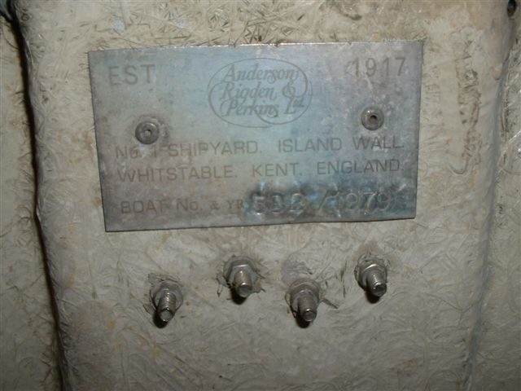
All the best Geoff

Adrian Jennings
16 September 2008 08:30

Hi Geoff
Some plate pictures attached. Only one other Mariner plate found at Rutland but no metal plate that I can see on this boat. Will have another look today when I am sailing. Think I have seen the Mariner mentioned in one of the articles so will have a look through.
Thanks for the information on the towing weights....got my figures from the trailer sailor article. Do you secure your keels when towing ? Mine rest on the trailer but clatter when going over bumps ! Worried that if they are suspended on the ropes , this will put too much strain on the ropes.
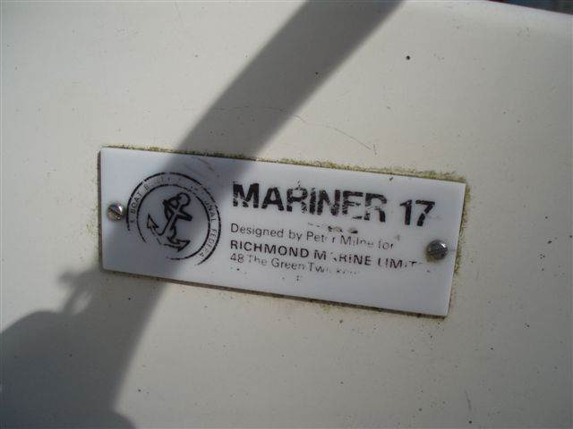
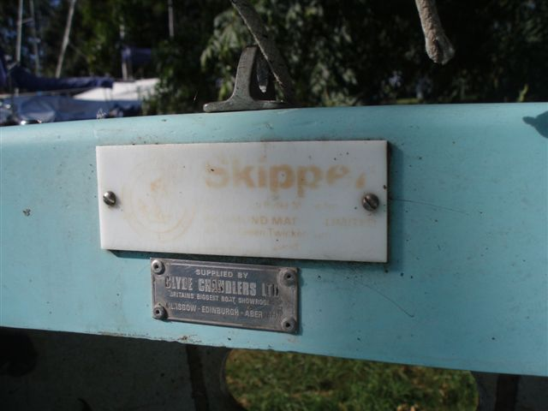
Had a great sail last night. Good steady Force 2 , fantastic sunset and no one else out on the water ! Adrian

Geoff Weller
19 September 2007 15:54
Hi Adrian
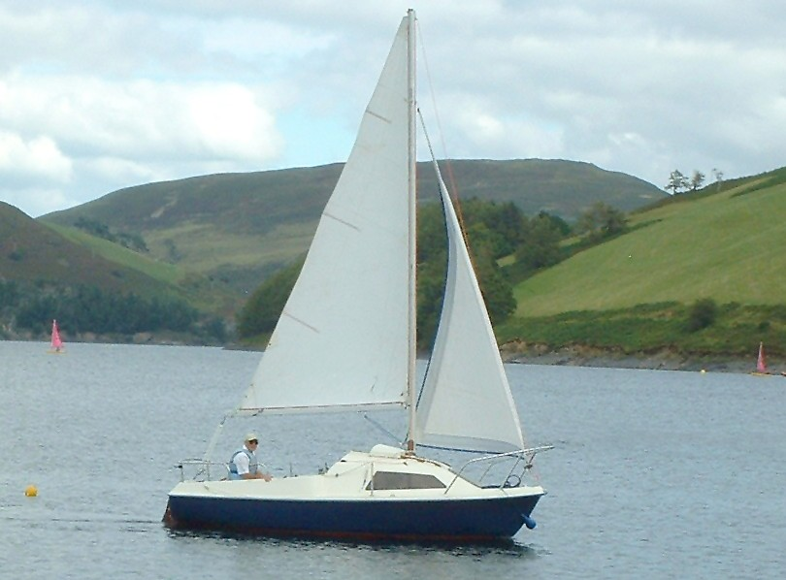
Last Saturday I went sailing. The weather was beautiful, with a nice breeze. A lovely day. Jo took some photo's, one of which is attached.

Regarding towing, I haven't felt the need to do anything special to secure the pivoting plates. The raising mechanism (rope, pulley block and wire)should be totally adequate to hold the plates up. I think they do rattle a bit over bumps, but then I have also heard the odd clank when sailing -there must be a bit of side-to-side play. In any case, if the rope did give way, the plates would only drop a few inches before contacting the trailer axle, so they wouldn't hit the road.
Thanks for the pictures - a variety all based on a similar theme. Please keep looking for metal plates, as you might yet find a clue to the date and origin of the 'Mariner' name.

Adrian Jennings
26 Sep 2007-11-17
Hi Geoff
Like the picture of your boat on the water....looks similar to mine. Also I note in Ellen Mc Arthurs autobiography there is a picture of her first boat which was a skipper 17 !

Found 2 more Skipper 17s and 2 Eagles in another boat park at Rutland..pictures attatched , but no plates. One of the eagles is in superb condition and has a nice cockpit awning. (Editor’s Note – pictures have been moved to http://myweb.tiscali.co.uk/skipper17/gallerypage2.html to reduce the size of this file).
I am currently having a cockpitcover/boom tent made up .....or a full winter cover...not sure which option yet but a local guy can tailor make what you want in a choice of materials and colours.

Adrian

Geoff Weller
17 Oct 2007
Hi Adrian
It was very disappointing here at the weekend - absolutely no wind again, very unusual for Mid-Wales, and grey and dismal. I decided to use the time to take my boat home for the winter. I am lucky enough to have a large shed (30 feet by 35 feet) so I don't need a winter cover, and I can do painting, maintenance, etc, inside.

I am planning to renew the forstay and do a few other jobs this winter. I notice that the keel plates are very rusty, and I am not sure whether to get them out and repaint them, or even to replace them with heavier gauge steel. Incidentally, are the spaces under the berths in your Skipper filled with plastic foam? Mine does not have any foam filling, and I don't know if this is unusual.

Best regards
Geoff

From: "Adrian Jennings"
To: "'Geoff Weller'"
Sent: Wednesday, October 17, 2007 6:18 PM
Subject: RE: Skipper pics
Hi Geoff
No foam visible except in the hull at the bottom by the tiller opening.
Great to have a proper shed.......shame about your weather at the weekend.
Adrian

From “Geoff Weller”
To “Adrian Jennings”
17 Oct 2007
Yes, I've got a little blob of foam at the bottom of the tiller opening,
too. It's black in colour and I don't know what it's for.
Geoff

From Peter Buiter
21 Oct 2007

Dear webmaster,
I am the owner of a skipper 17. I bought it some weeks ago, and sailed on a lake with it. Unfortunately my frontsail (fok in Dutch) was ripped in pieces and the next time the rudder broke down.....
So I have something to do this winter. If you want I can send you some pics of the boat.
with greetings, Peter Buiter

From Geoff Weller
21 Oct 07

Hi Peter
Congratulations on owning a Skipper 17. Sorry to hear about the damage to your foresail (often called a jib in the UK) and rudder. There is never any shortage of jobs to do on a boat!
I would indeed like a picture of your Skipper. Do you have one showing the sails up? I have attached a photograph of my boat sailing on Llyn Clywedog, a lake in Wales near where I live. As you can see, we have hills here.
Does your boat have a metal nameplate showing the boatbuilder, boat number and year of manufacture? If so, could you tell me what it says on the plate (or send a photograph of it)? The information may help me to get more detail on the history and development of the Skipper 17

Best regards
Geoff.

From Peter Buiter
21 Oct 07

Hi Geoff
Thank you for your reaction.
I' m sorry, I don't have a picture with sails on it. When I'm sailing I'm allways the one that's taking them....
And before I got the change for a picture it broke down.
The sailnumber is S 190 and the sails are made by Jack Holt. I wonder if this are the sails that came with the new boat.
The first time I sailed with it (alone|) the jib ( a roll one) broke down, because of weakness of the material by influence of the sun. You know what I mean.
Therefore I put another jib from my Pollywood ( an open smaller boat I own)
Later the rudder broke down, it was not the original. I would like to see a picture of an original one. Is it made from wood or metal etc.
A friend of mine is very handy with wood and boats, he will make a new one this winter.
A new sail will be made also this winter. I don't have the original measures, but when I bring the old one the sailmaker can do his job.
There is a plate in the back of the boat but it is rather vague. Tomorrow I 'll make some pics for you.
I put some pics somewhere on the skipper yahoo area, but cannot find them back. So I put them also on my Flickr account, look at http://picasaweb.google.com/fotobuiter
As you will discover, this is the same boat as shown on your site !
Very happy to hear from you Geoff, I wonder how many Skippers still exist, and how many there are here in the Netherlands.
Greetings
Peter

PS
I forgot to complimentize ( is this English..) you with your nice Skipper. She looks good and well preserved to me. Is there any wind left between those mountains ?

From Geoff Weller
23 Oct 07

Hi Peter
Yes, I know what you mean, I only rarely get a photo of my boat sailing, because I am the person sailing it.
I like the photographs on your picasaweb site. How long have you had your boat?
The boat number must have information about the age, but I do not have the year-by-year information. All I know for certain is:
Skipper Number 74 was made in 1973 and
Skipper Number 582 (my boat) was made in 1979
My guess is that your boat, Number 190, was made about 1974.
Does your Skipper have one pivoting keel plate, or two?
Can you send me a picture of your nameplate, even if the printing is vague?
My jib is from Cranfield Sails, fits on a roller, and has dimensions are follows
Foot (under) 2515 mm
Luff (front) 4460 mm
Leach (back) 4345 mm
My rudder is hardwood. I attach pictures showing how it is made. Let me know if you need more measurements. (Note the pictures are on the Modifications page of the Skipper 17 website)

Best regards
Geoff

From Greg Darby
23 Oct 07

Dear Geoff
Skipper 17 website is shaping up very nicely - my compliments for doing a great job which benefits all of us. Thanks.
One thing, though, is that it doesn't seem to appear on Google results after a search of "Skipper 17". I presume there are some tricks to improve Google's ranking, although I don't know them. I think that if we can get references to the site on other big sites (such as YBW etc) then it pushes up the rankings.
Is there anywhere we can send stuff to for inclusion on the site?
Have currently got my twin-plate cabin boat out of the water for long overdue overhaul. It sat in Chatham Marina for 13 months without antifouling (!), and when I beached it after a summer away from it, I found about 4 inches of mussel growth over the entire underside. No wonder it was motoring like a house brick!
Anyway, currently:
1. Dropped both keel plates for blasting and galvanising (about £40 each). Very straightforward job
2. New windows being made -both mine were cracked and holed (about £130)
3. New sails - both genoa and main were very tatty and shapeless. UV sacrificial strip on genoa had completely gone. Will patch them as spares later. New sails from Crusader Sails in Poole would normally be £580 but I got a deal as they had a part completed set in their store.
4. New rubbing strip/fendering. Old wooden one was rotted and split. Will replace with B section rubber fendering from Bridge Rubber & Plastics of Southampton £5 per metre
5. Fit drain holes to forward end of cockpit floor
6.Recoat and antifoul bottom.
7.Two pack polyurethane paint to upper parts - deck, cockpit, cabin roof, foredeck
8. Revarnish grab rails, cockpit seat extensions, rudder
9. Replace flattened, worn lines, halyards and sheets.
That should keep me busy for the next few months and hopefully should no longer mean that my boat looks like it just crossed the Atlantic in a gale (or has been seriously neglected).
I'm happy to give you an account of the main bits if you want one.
Regards
Greg Darby

